# Introduction

The Switch Adapted Bubble Blower is an adapted bubble machine that can be used with a 3.5 mm assistive switch. There is also the Switch Adapted Bubble Machine in the MMC library – this bubble blower is a couple of years old and is finding harder and harder to source so there was a need for another bubble machine to be added to the site that is easier to source. This Gazillion Tornado Bubble Machine can be found at Walmart or online at several locations including Amazon.

This switch adapted bubble machine may be beneficial to someone who may have difficulties pressing the original small button due to its size, location, or required activation force.

# Research

### Commercial Options:

[Switch Adapted Bubble Machine](https://www.amazon.com/Switch-Adapted-Machine-Adaptive-Special/dp/B086VW7FCB)  $109.69

[Paw Patrol Bubble Blower Adaptive Toy](https://www.rehabmart.com/product/paw-patrol-bubble-blower-adaptive-toy-42084.html) $84.67

### DIY Options:

[SWITCHED Adapted Toys - Blitz Bubble Blowout (Bubble Machine) - Manual - YouTube](https://www.youtube.com/watch?v=jYjGyDc3ZvU)

[Switch Adapted Bubble Machine With a Battery Interrupter - YouTube](https://www.youtube.com/watch?v=lFd772iZ0R4)

[Switch Adapted Toys - Bubble machine - YouTube](https://www.youtube.com/watch?v=Pen46b0XpRo)

# Requirements

## Goals

|  |  |
| --- | --- |
| G01 | Adapt an easy to source bubble machine. |

## Functional Requirements

|  |  |
| --- | --- |
| F01 | Toy is relatively easy to adapt so that others can do it themselves with our assembly manual. |

# Ideation

To adapt this easy to source and affordable bubble machine I found at Walmart.

# Conceptual Design

## Concept 1

The original idea was to adapt this toy by adding a mono jack in parallel with the existing switch. It was also planned to have the jack placed somewhere within the large green portion of the bubble blower. After opening the toy up, it was found that there was really no room to fit a jack. The final placement of the jack will be shown in the “Detailed Design” section.

# Testing

The toy was tested by plugging in a 3.5 mm switch into the mono jack in the adapted bubble blower.

# Detailed Design

The bubble machine was adapted using a 3.5 mm mono jack that was soldered in parallel with the original switch so that the original on/off button also works. One of the switch ends was easy to access, but the other wasn’t. In result, one of the original switch wires was stripped so that the new wire could be soldered directly to it as there wasn’t enough room to solder to the wires end. This was done by carefully cutting opened the wire as shown below.

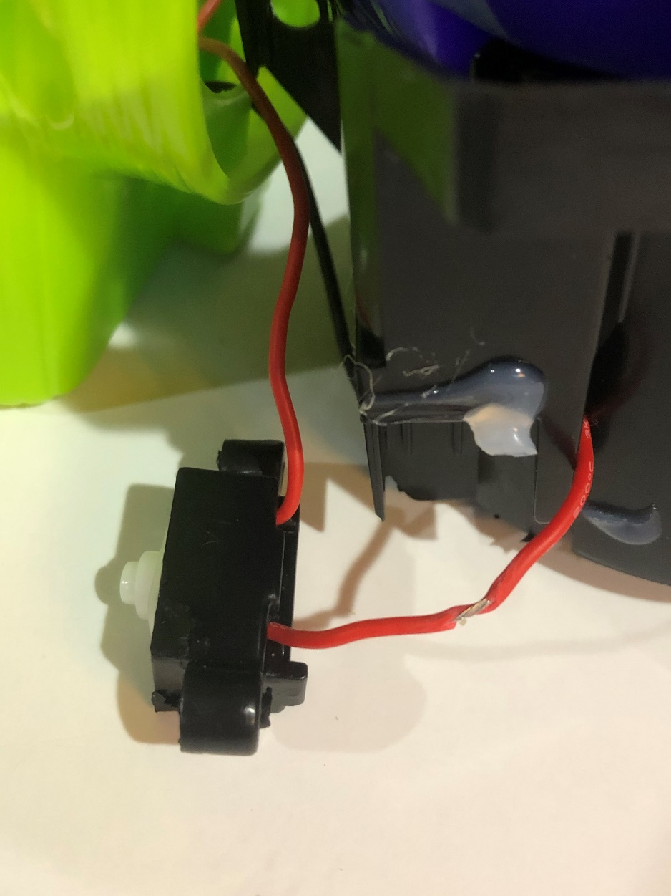

As shown below, the mono jack is located in the purple base of the device. This is because there wasn’t enough room inside the green part of the device.

# Opportunities for Improvement

* If possible, get the mono jack to fit up inside the green part of the device.